[**SETTING UP APPLICATION ENVIRONMENT**](https://careereducation.smartinternz.com/Student/guided_project_workspace/41121#collapse1)

**Create Flask project**

**Install flask:**

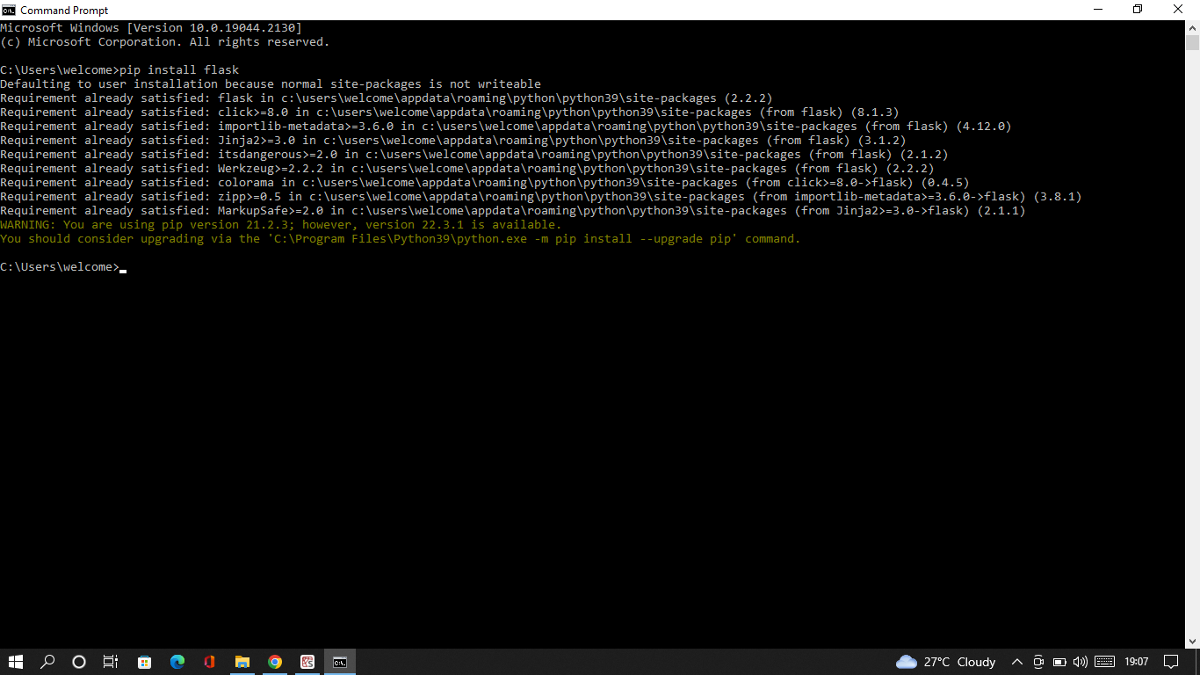

**Flask code:**

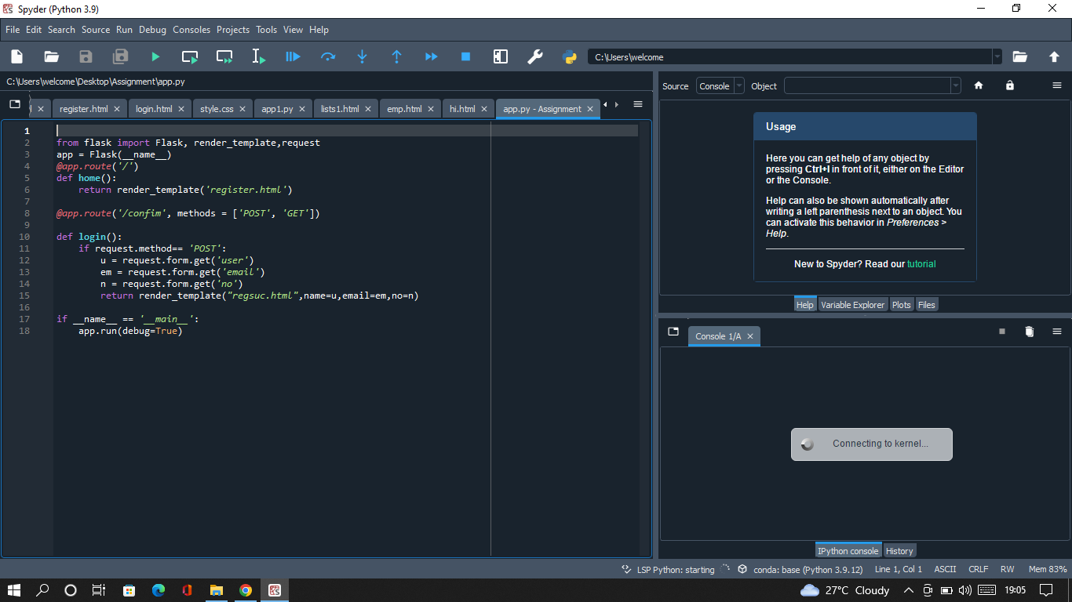

**Run Flask application:**

